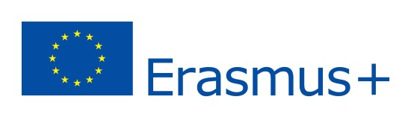 Here comes the Sun(power) 2016-2018
CHECKLIST UP TO MEETING IN TARRAGONA
MEETING DATES: TARRAGONA 5th -11th March 2017

ACTIVITY | WHEN | WHO
- Students' selection (Every country has its own criteria) | OCTOBER | All the partners
- Students' profiles to be prepared and shared with the others in order to start knowing each other. | NOVEMBER | All the partners
- Upload the students' profiles on the eTWINNING. | NOVEMBER | All the partners
- SKYPE conference schedule | NOVEMBER | SPAIN
- Create a logo ( a contest will be taken in Spain and every country will present theirs. Then, the best one will be chosen by a students' and teachers polling). | MARCH | All the partners
- START of SKYPE conferences (The conferences will take place from beginning December until the meeting in Spain with all the partners). | DECEMBER to MARCH | All the partners
- Upload our school presentations in HERE COMES THE SUN (POWER) Website. | OCTOBER | All the partners
8. STUDENTS' presentations about HOW SUN power is exploited in our different countries. (10 minutes presentation...films, powerpoint, sketches....) | MARCH (meeting in Spain) | All the partners
9. A questionnaire will be sent by Poland to be filled by the other partners ( students) | OCTOBER | POLAND
10. All the partners will answer a feedback questionnaire in SPAIN. | MARCH (meeting in Spain) | All the partners
11. Sharing and disseminating in social networks, local media, school websites, community the results of our work. | APRIL | All the partners
12. Checklist for the meeting in Poland. | MARCH (meeting in Spain) | All the partners

